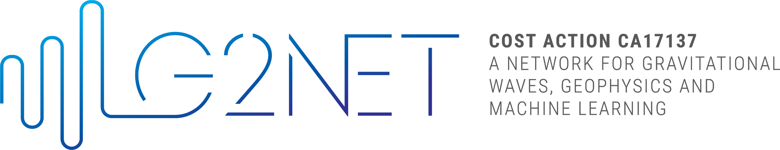

SHORT TERM SCIENTIFIC MISSION (STSM)
SCIENTIFIC REPORT

This report is submitted for approval by the STSM applicant to the STSM coordinator

Action number: CA17137
STSM Title:
STSM Start date:
STSM End date:
Grantee Name:

Purpose of the STSM (max 200 words):

Description of work carried out during the STSM (max 500 words):

Description of the main results obtained (max 500 words):

Future Collaborations (if applicable):

How the action has helped me in my research and personal comment about the STSM (max 200 words):
(we will publish this information in the webpage for outreach purposes)

